HW1 0511097 黃柏豪

1. Gauss-Jordan method:

For each time we need make some elements become 0, to achieve an upper triangular, so in the first time, we will need $n^{2}$ times multiplication and $n^{2}$ times subtraction, in second time we will need ${(n-1)}^{2}$ times multiplication and ${(n-1)}^{2}$ times subtraction and so on.

Totally we will need: $$2\sum_{1}^{n}{i^{2}}≅O(n^{3})$$

$$∴The complexity of using Gauss-Jordan method to solve x is O(n^{3})$$

1. Cofactor method:

We use det built-in function in Matlab and it compute triangular factors obtained by Gaussian elimination with the LU function. To compute determinant, the time complexity is $O(n^{3})$. For $n^{2}$ elements, we will compute each determinant, so totally we need O($n^{5}$).

$$∴The complexity of Cofactor method is O(n^{5})$$

1. Inverse:

We use built-in function to calculate inverse of matrix A

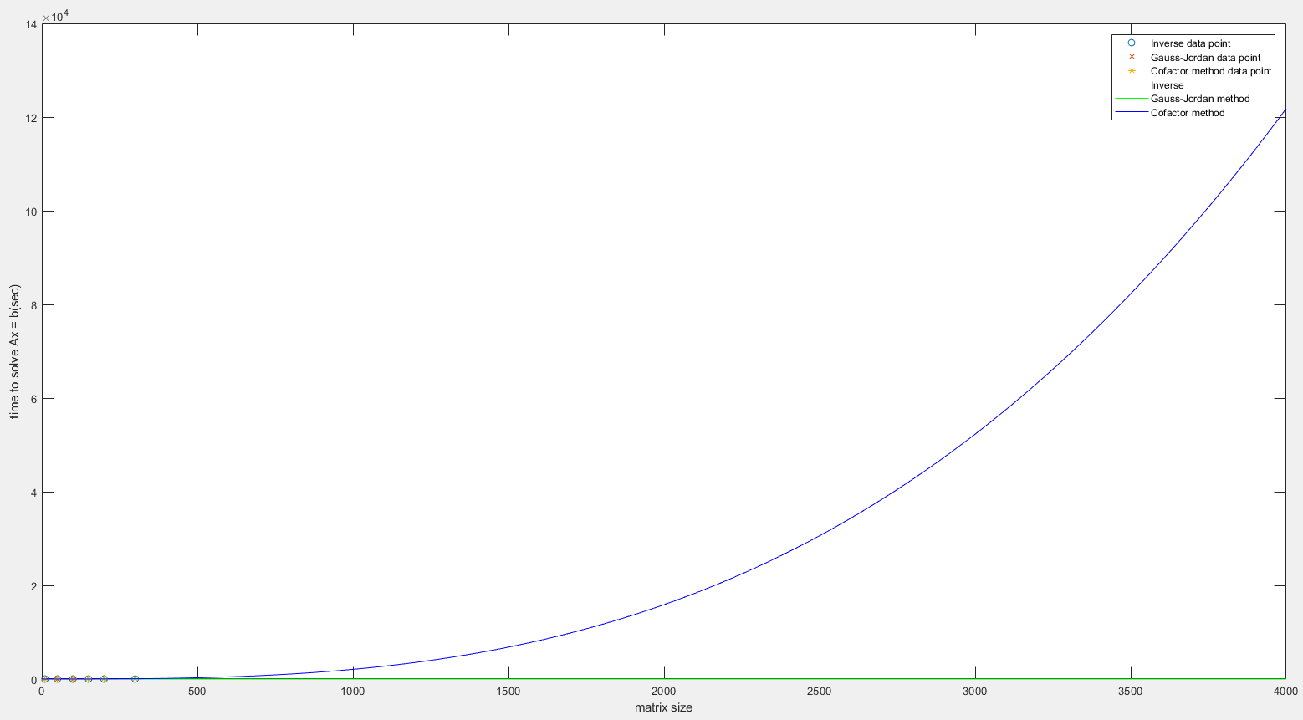

The red line is inverse method, and it almost overlaps with green line (Gauss-Jordan method)